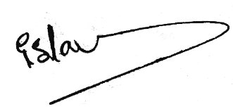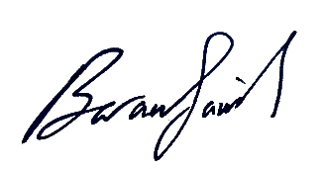

**Testifies That**

**DOA’A MAHMOUD AHMAD ALBALAWNEH**

**Has successfully demonstrated the skills and competences in the training course**

**Certified Montessori Methodology Diploma in Education**

**(Birth - 12 Years Old)**

**And has achieved the required studies with the highest degree of competence and skill, and in recognition of us, is hereby awarded Certificate of Achievement**

**Therefore, we testify here to put our name, signature and the stamp on July 01, 2024**

**Duration: 160 Hours**

**Eng. BARA’ SBEIH** **Ms. ISLAM OTOUM**

**Sensorial Life Academy Montessori Trainer**

www.amc-llc.us

Certification No: AMC-200501

Wyoming Secretary of State American Montessori Center LLC Original ID: 001077123-2022